**Task of cloud-trail and cloud-watch**

1. **Enable CloudTrail monitoring and store the events in s3 and CloudWatch log events.**

**Create trail from cloud trail  
b. Select new s3 bucket, enable log validation, SNS   
Notification, select SNS topic and new CloudWatch.  
c. Go to SNS service create topic create subscriptions select   
Protocol as mail and give mail id and create.  
d. Check mail and confirm then SNS created.  
e. Now came to CT tab and select SNS existing which is created   
by us.  
f. Disable Log file SSE-KMS encryption.  
g. Select any one or select Management events.  
h. Create trail.**

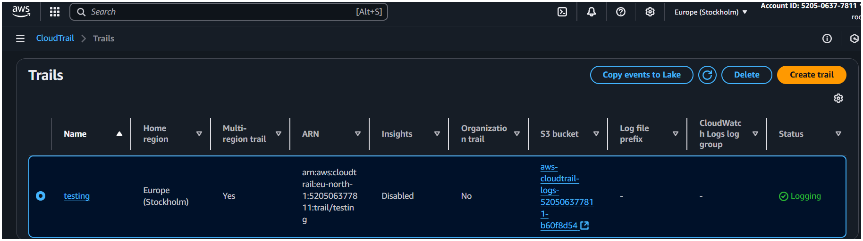

**open above s3 bucket open it then you’ll be redirected to the s3 bucket and the cloud trail > open till you get the object down below.**

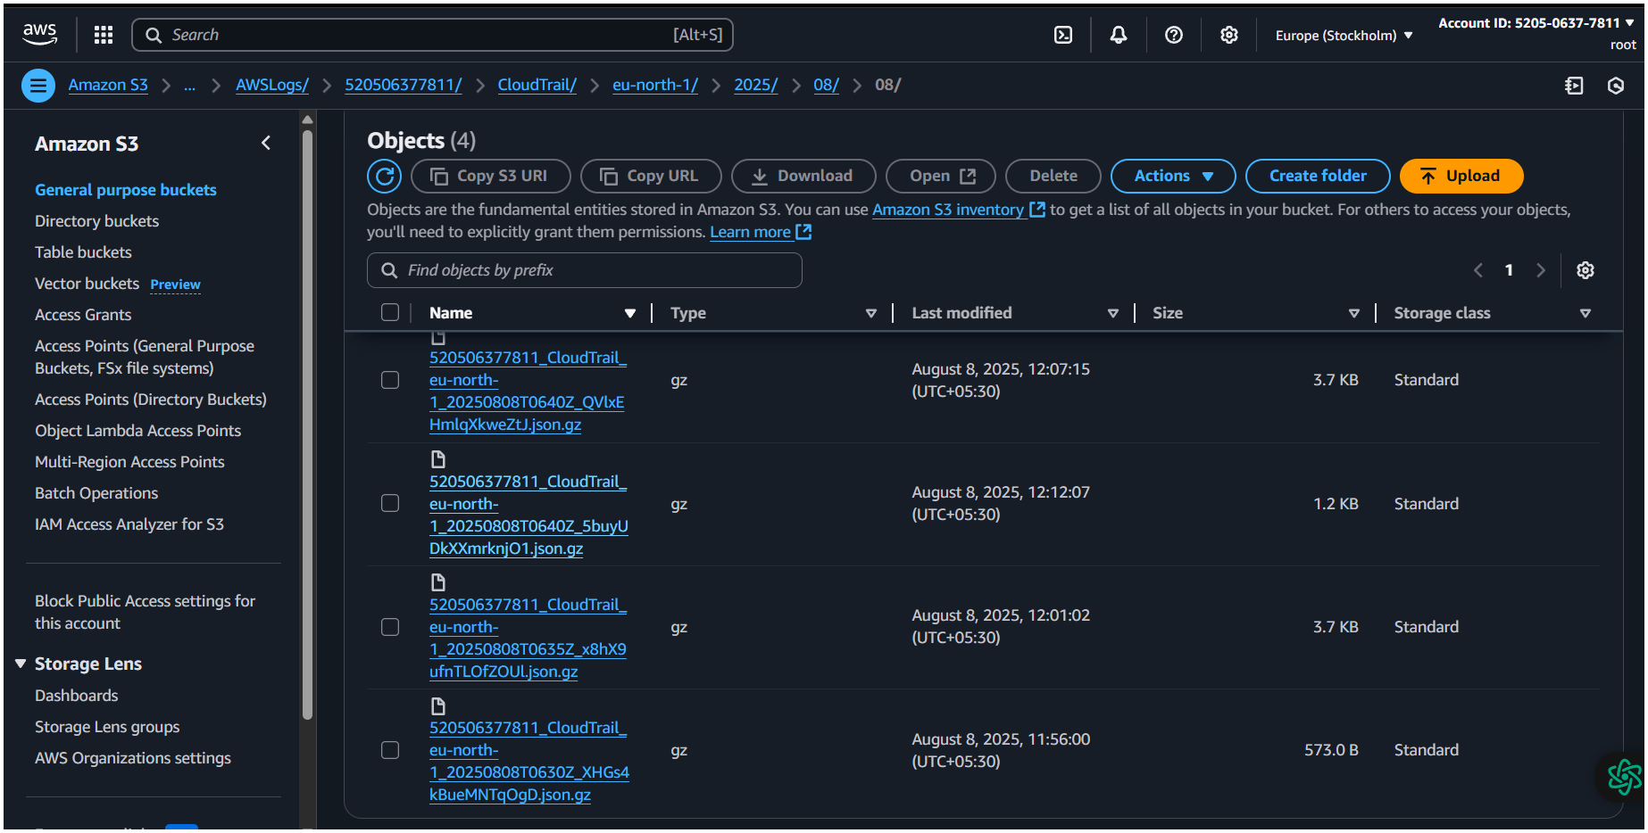

**2) Enable SNS for cloudtrial to send alert on email.**

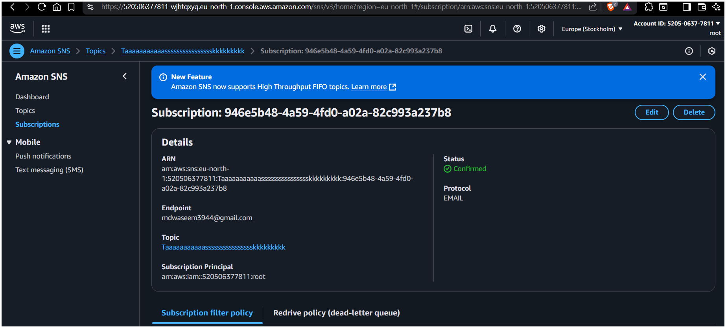

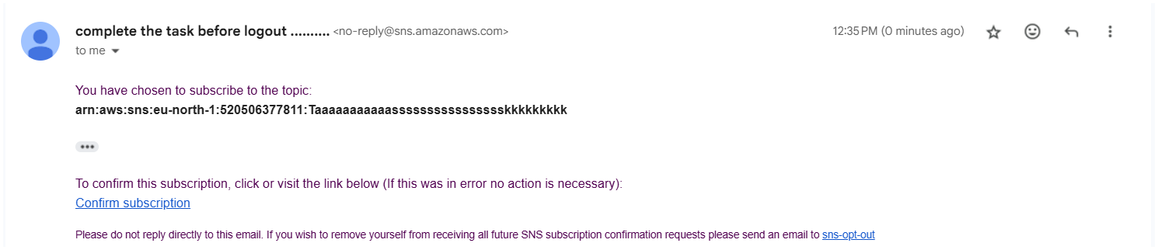

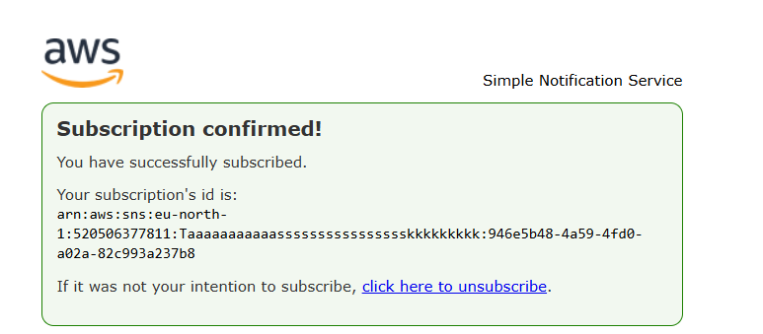

**3)Configure cloud watch monitoring and record the cpu utilization and other metrics of ec2.**

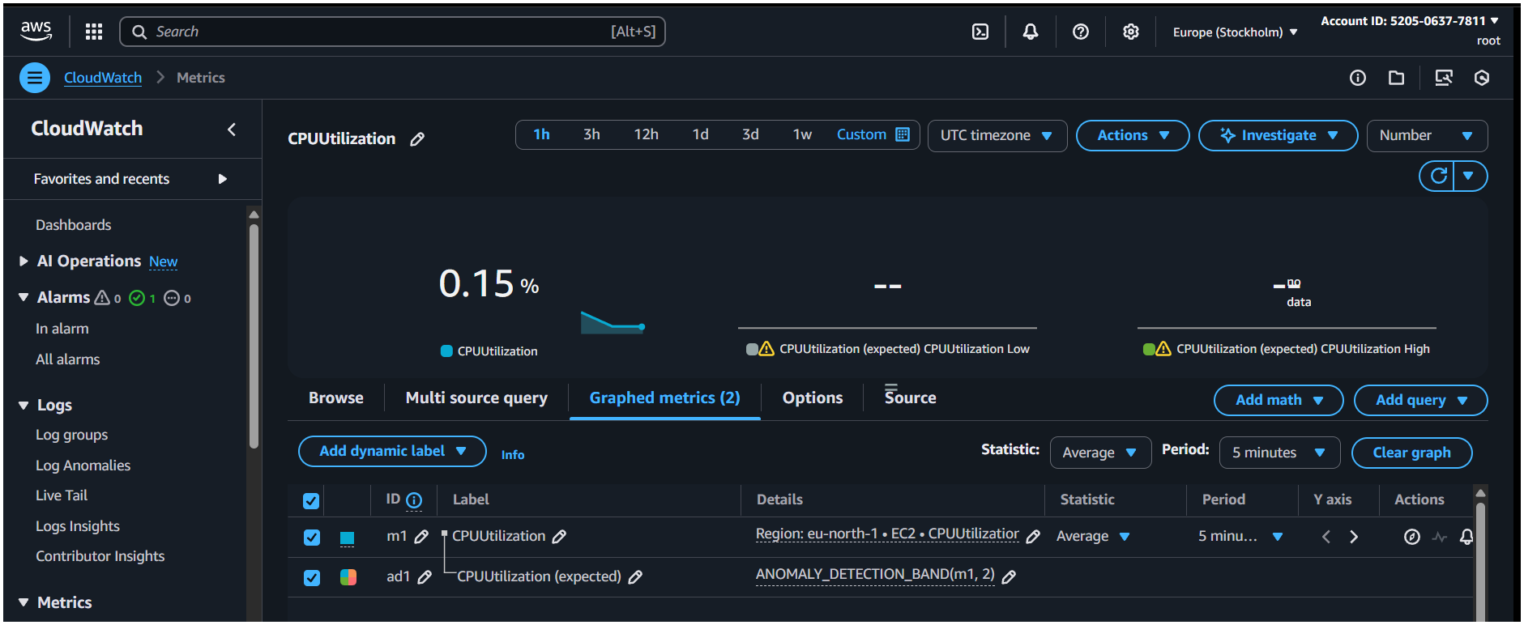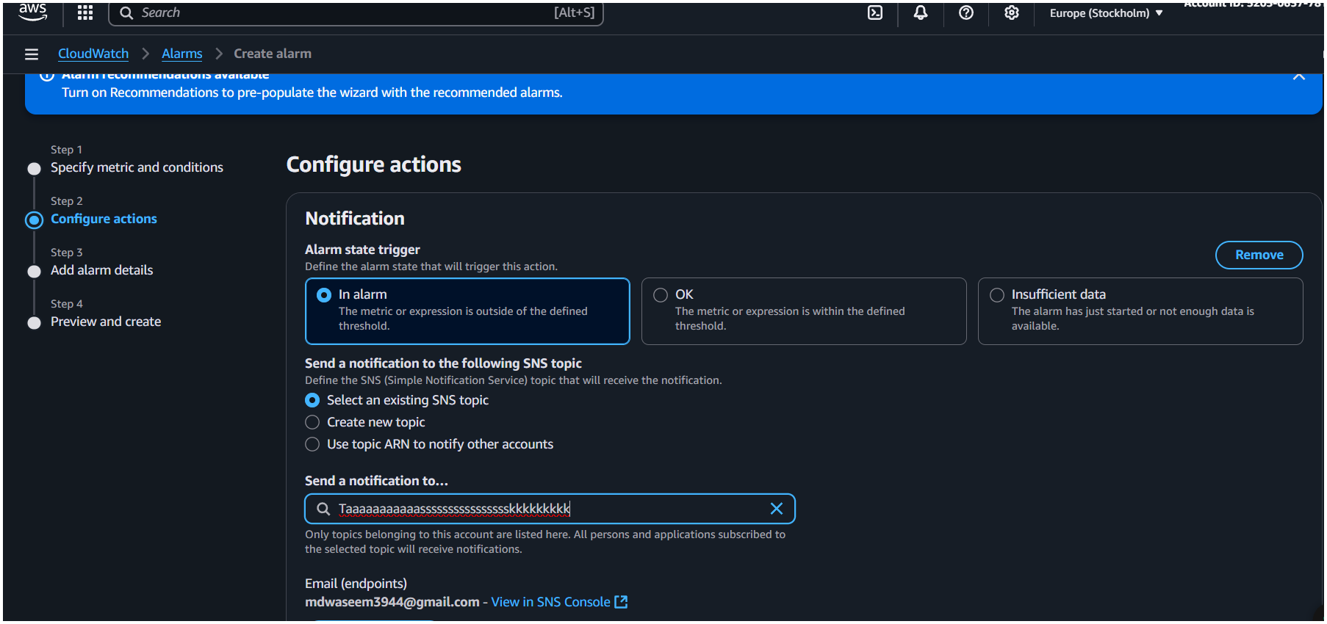

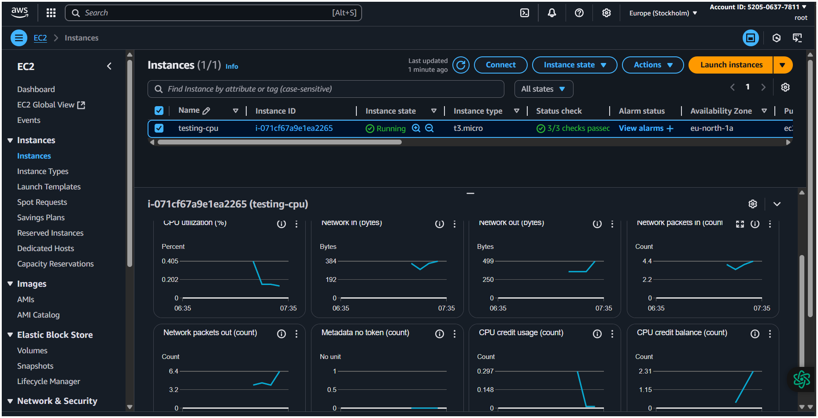

**5)Create one alarm to send alert to email if the cpu utilization is more than 70 percent.**

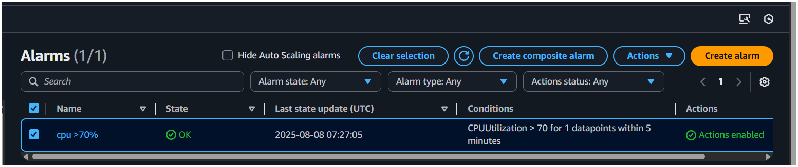

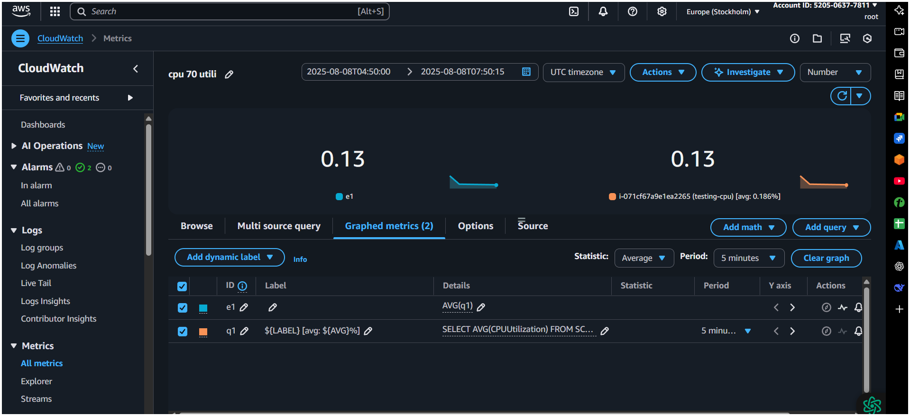

**5-Create Dashboard and monitor tomcat service wether it is running or not and send the alert.**

**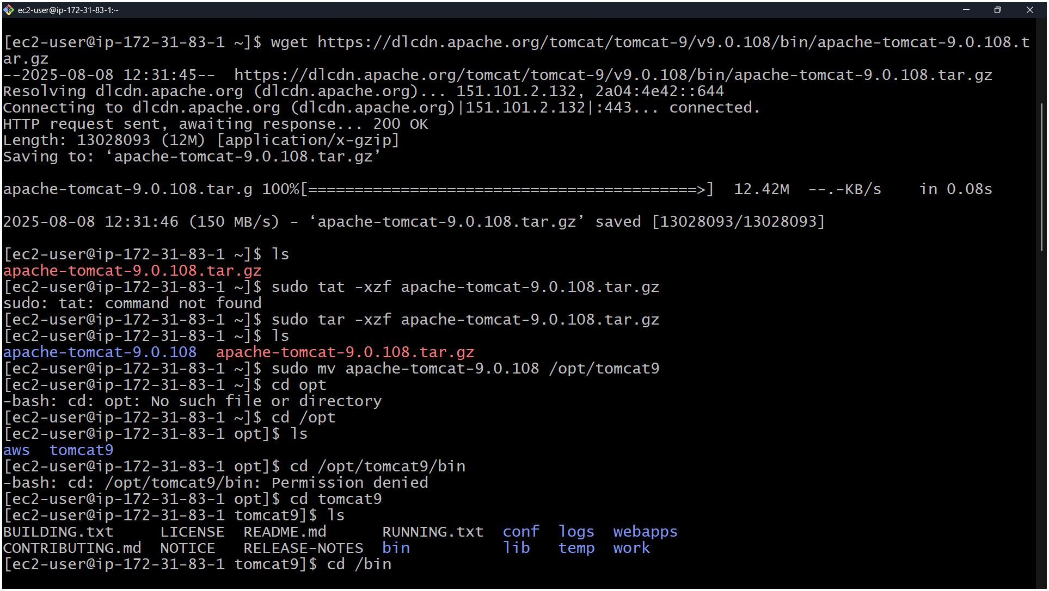  
vi monitoring  
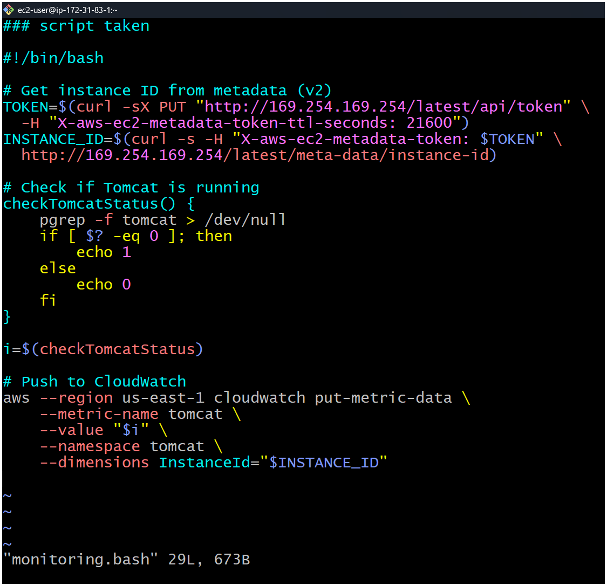  
crontab -e**

**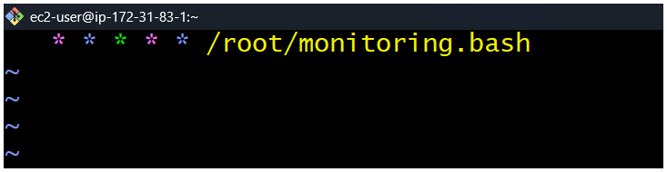  
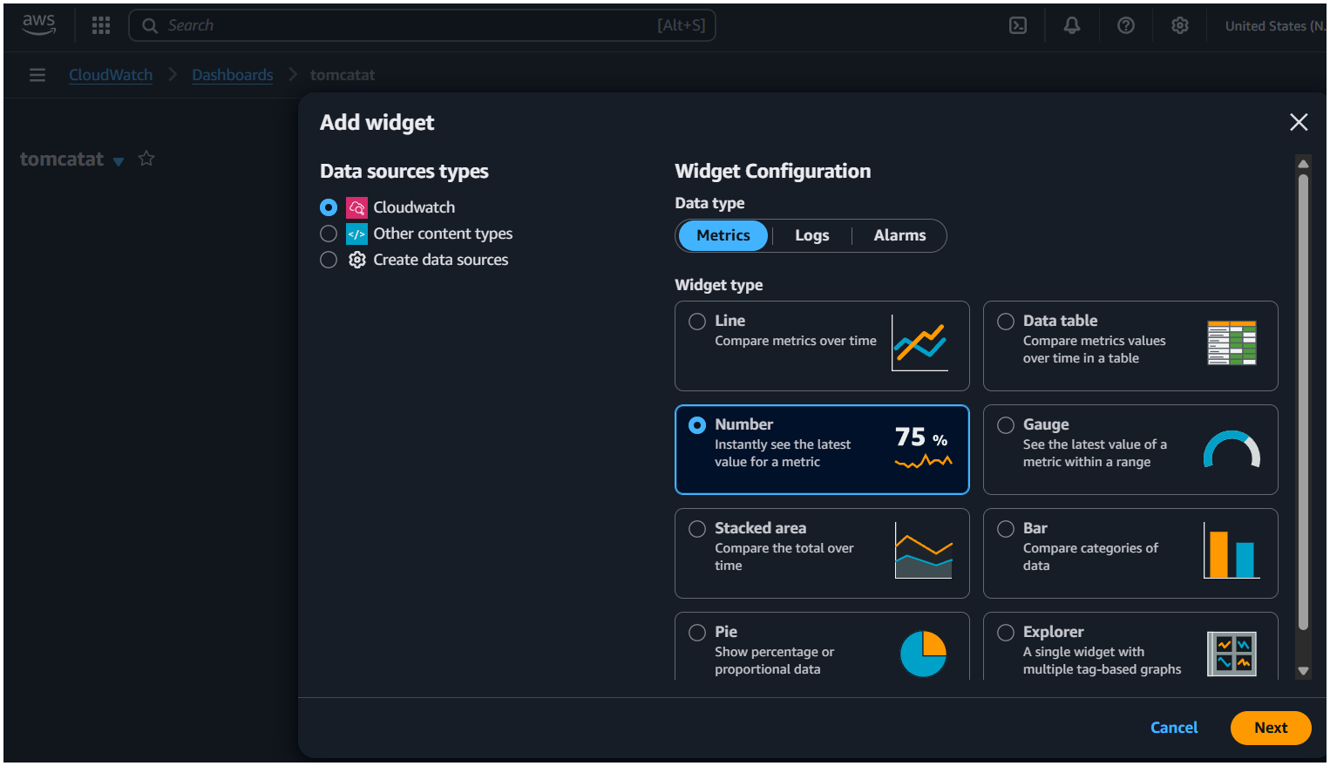  
  
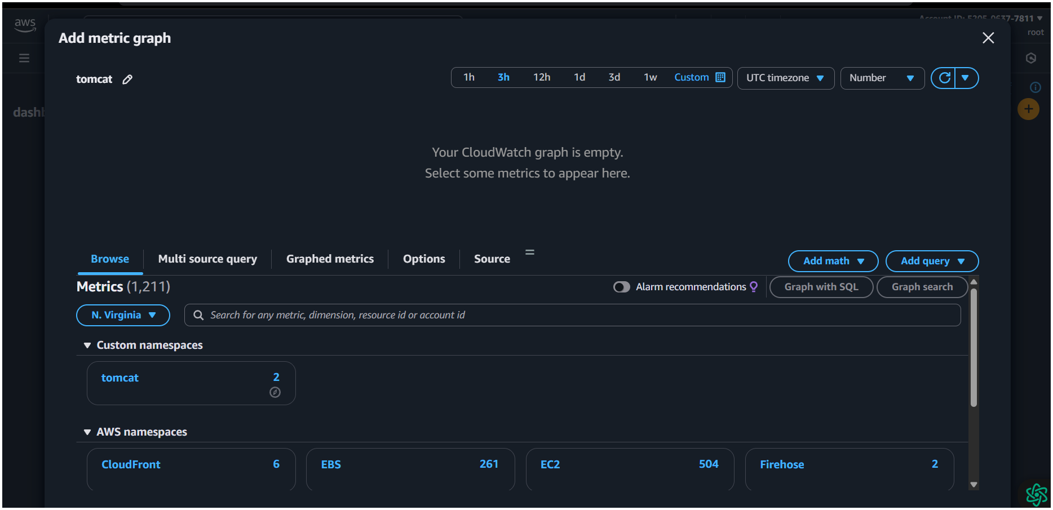**

**6-Create Dashboard and monitor nginx service to send the alert if ngitnx is not running.**

**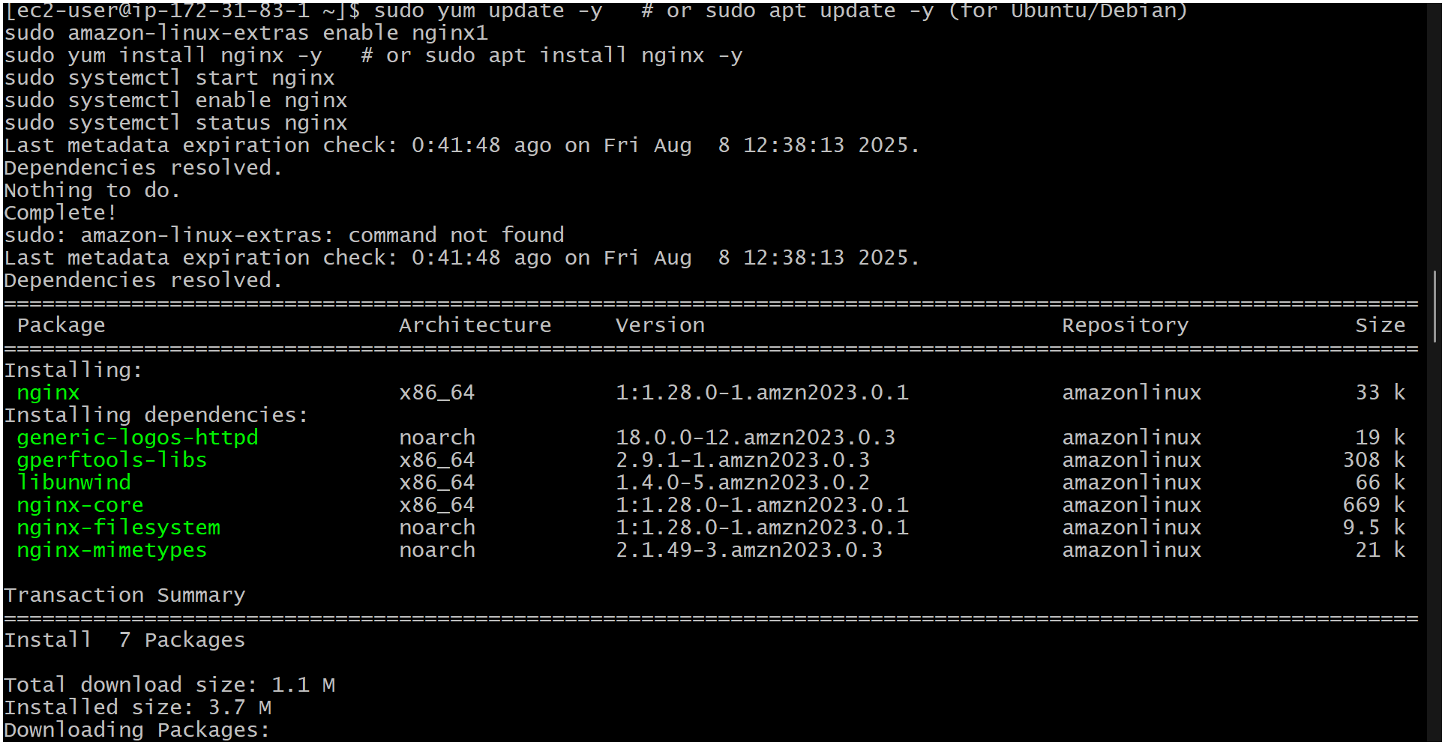  
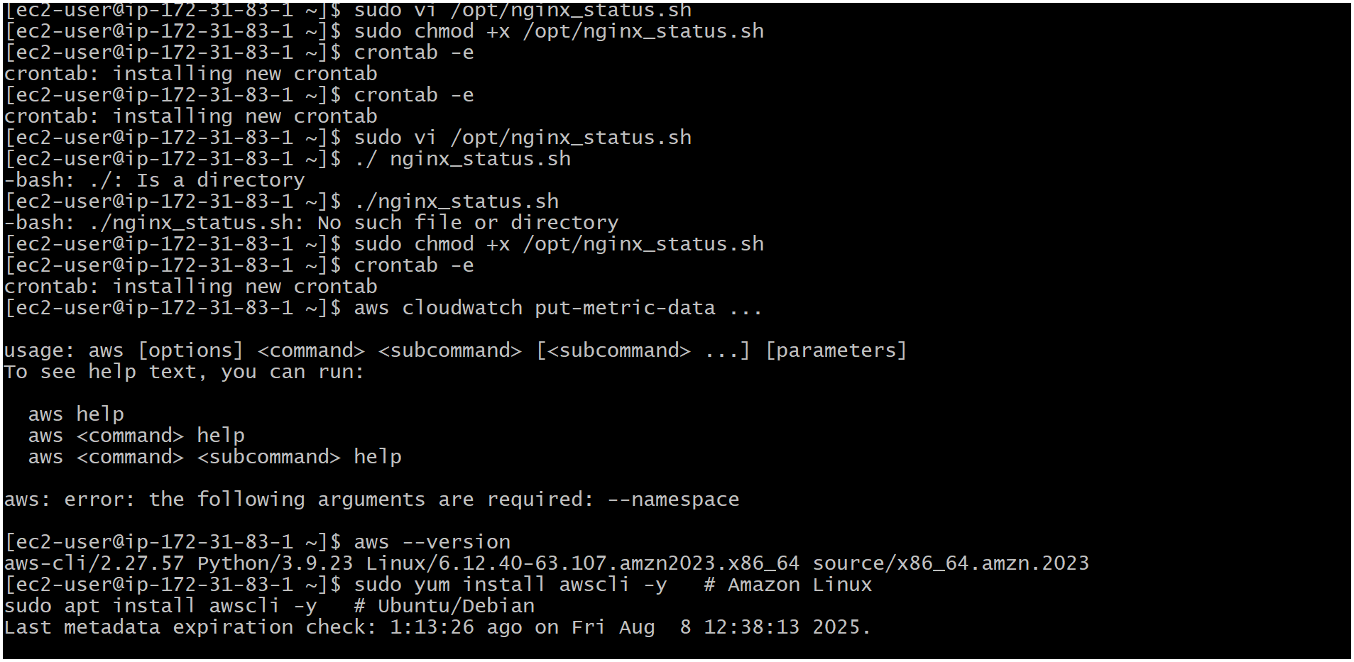  
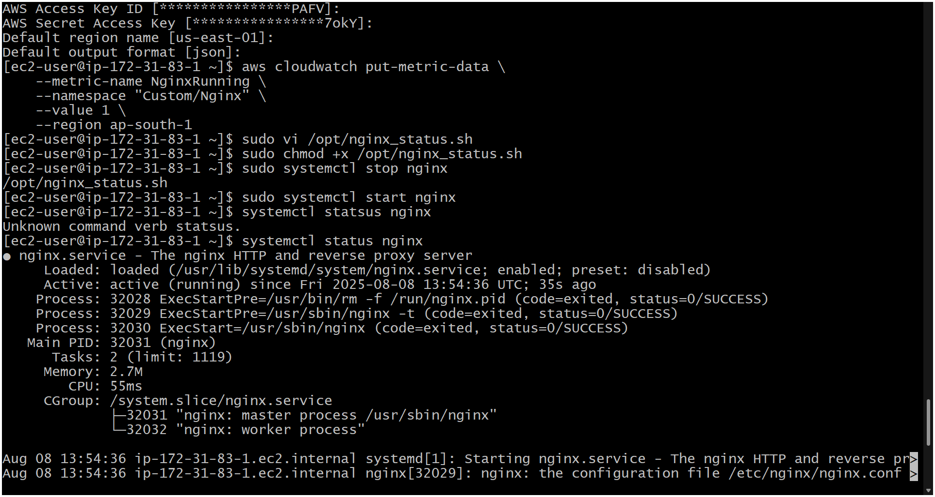  
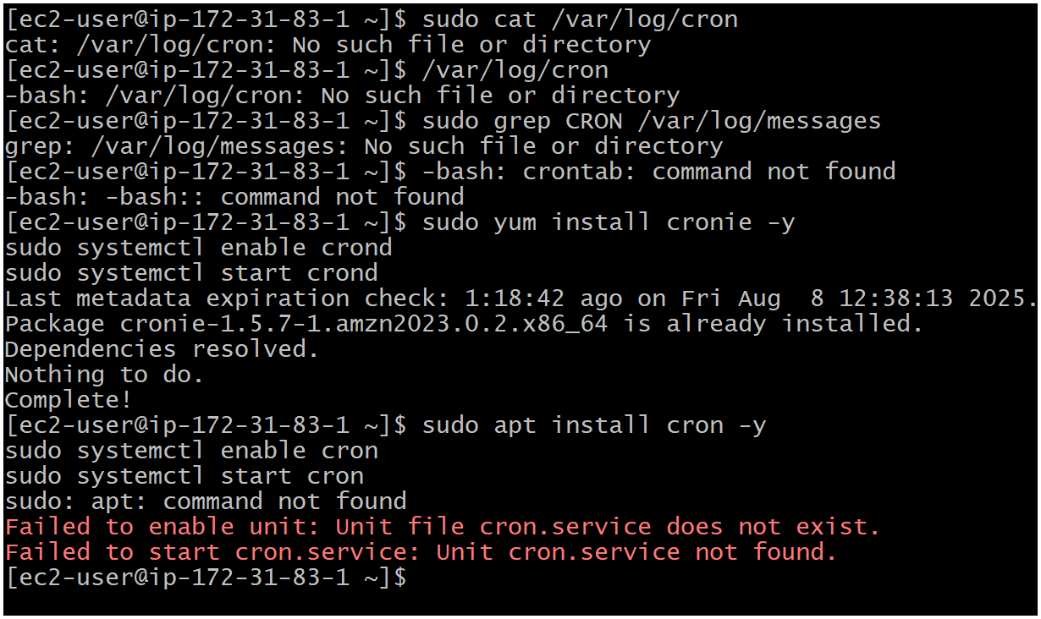**

* + **Go to AWS Console → CloudWatch → Alarms → Create Alarm.**
  + **Select metric → Custom → Custom/Nginx → NginxRunning.**
  + **Statistic: Maximum.**
  + **Period: 1 minute.**
  + **Condition: Threshold → "Lower than" → 1 (means Nginx not running).**
  + **Add an SNS Topic to send alerts:**

**If you don’t have one, create:**

* + **Go to SNS → Create Topic → Standard.**
  + **Give it a name (e.g., NginxAlertTopic).**
  + **Create a subscription with your email.**
  + **Confirm email from AWS.**

**Link the SNS topic to the alarm.**

**Create the alarm.**